**Pizza Sales Project**

**Problem Statement**

The objective of this project is to analyze the sales data of a pizza company to gain insights into their sales performance, customer behavior, and popular pizza types.

**Project Steps**:

1. Data Collection: Collect sales data from the pizza company, including information such as order date, pizza type, quantity, price, and customer details.

2. Data Cleaning: Clean the data to remove any inconsistencies, missing values, or duplicates. Ensure that the data is in a format suitable for analysis.

3. Data Storage: Store the cleaned data in a MySQL database to facilitate easy access and management.

4. Data Analysis: Use Power BI to connect to the MySQL database and create visualizations to analyze the sales data.

5. Data Visualization: Create interactive dashboards and reports in Power BI to visualize the analysis results. Use charts, graphs, and tables to present the data in a clear and insightful manner.

6. Insights and Recommendations: Based on the analysis, derive insights into the sales performance and customer behavior. Provide recommendations to improve sales and customer satisfaction.

7. Final Presentation: Prepare a final presentation summarizing the analysis findings, insights, and recommendations. Present the findings to stakeholders for decision-making.

**Benefits**: This project will help the pizza company understand its sales trends, customer preferences, and areas for improvement. It will enable data-driven decision-making to drive business growth and customer satisfaction.

**KPI’s Requirement**

We need to analyze key indicators for our pizza sales data to gain insights into our business performance. Specifically, we want to calculate the following metrics:

1. Total Revenue: The sum of total price of all pizza orders.
2. Average Order Value: The amount spent per order, calculated by dividing the total revenue by the total number of orders.
3. Total Pizza Sold: The sum of quantities of all pizza sold.
4. Total Orders: Total number of orders placed.
5. Average Pizza Per Order: The average number of pizzas sold per order, calculated by dividing the total number of pizzas sold by the total number of orders.

**Charts Requirement**

We would like to visualize various aspects of our pizza sales data to gain insights and understand key trends. We have identified the following requirements for creating charts:

1. Daily Trend for Total Orders: Create a bar chart that displays the daily trend of total orders over a specific time period. This chart will help us identity any patterns or fluctuations in order volumes on a daily basis.
2. Monthly Trend for Total Orders: Create a line chart that illustrate the hourly trend of total orders throughout the day. This chart will allow us to identify peak hours or periods of high order activity.
3. Percentage of Sales by Pizza Category: Create a pie chart that shows the distribution of sales across different pizza categories. This chart will provide insights into the popularity of various pizza categories and their contribution to overall sales.
4. Percentages of Sales by Pizza Size: Generate a pie chart that represent the percentage of sales attributed to different pizza sizes. This chart will help us understand customer preference for pizza sizes and their impact on sales.
5. Total Pizzas Sold by Pizza Category: Create a funnel chart that presents the total number of pizzas sold for each pizza category. This chart will allow us to compare the sales performance of different pizza category
6. Top 5 Best Sellers by Revenue, Total Quality and Total Orders: Create bar chart highlighting the top 5 best-selling pizzas based on revenue, total quality and total orders. This chart will help us identify the most popular pizza option.
7. Bottom 5 Worst Sellers by Revenue, Total Quality and Total Orders: Create bar chart highlighting the Bottom 5 worst-selling pizzas based on revenue, total quality and total orders. This chart will help us identify the underperforming of less popular pizza option.

**Features**

This pizza sales dataset makes up 12 relevant features:

* order_id: Unique identifier for each order placed by a table
* pizza_name_id: Unique identifier for each pizza placed within each order (pizzas of the same type and size are kept in the same row, and the quantity increases)
* pizza_id: Unique key identifier that ties the pizza ordered to its details, like size and price
* quantity: Quantity ordered for each pizza of the same type and size
* order_date: Date the order was placed (entered into the system prior to cooking & serving)
* order_time: Time the order was placed (entered into the system prior to cooking & serving)
* unit_price: Price of the pizza in USD
* total_price: unit_price * quantity
* pizza_size: Size of the pizza (Small, Medium, Large, X Large, or XX Large)
* pizza_category: Unique key identifier that ties the pizza ordered to its details, like size and price
* pizza_ingredients: ingredients used in the pizza as shown in the menu (they all include Mozzarella Cheese, even if not specified; and they all include Tomato Sauce, unless another sauce is specified)
* pizza_name: Name of the pizza as shown in the menu

**MYSQL**

1. **Total Revenue**

* SELECT SUM (total_price) AS total_revenue FROM pizza_sales;

OUTPUT:

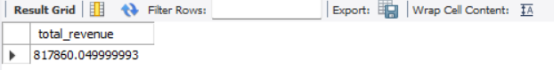

1. **Average Order Value**

* SELECT SUM (total_price) / COUNT (DISTINCT order_id) AS Average_Order_Value FROM pizza_sales;

OUTPUT:

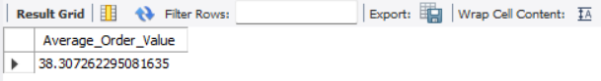

1. **Total Pizzas Sold**

* SELECT SUM (quantity) AS Total_Pizzas_Sold FROM pizza_sales;

OUTPUT:

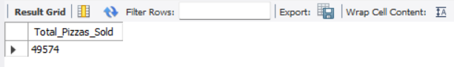

1. **Total Orders Placed**

* SELECT COUNT (DISTINCT order_id) AS Total_Orders_Placed FROM pizza_sales;

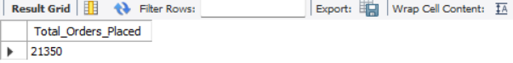

1. **Average Pizzas per Order**

* SELECT CAST (SUM (quantity) / COUNT (DISTINCT order_id) AS DECIMAL (10,2)) AS Average_Pizzas_per_Order FROM pizza_sales;

OUTPUT:

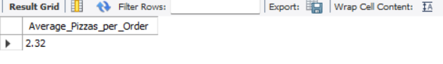

1. **Daily Trends for Total Orders**

* SELECT DATE_FORMAT (order_date, '%W') AS Order_day, COUNT (DISTINCT order_id) AS Total_Orders FROM Pizza_sales GROUP BY Order_day;

OUTPUT:

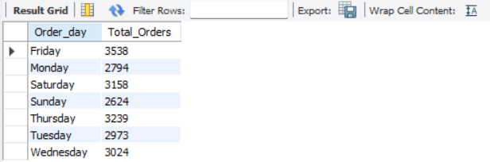

1. **Monthly Trend for Total Orders**

* SELECT DATE_FORMAT (order_date, '%M') as Order_Month, COUNT (DISTINCT order_id) as Total_Orders FROM Pizza_sales GROUP BY Order_Month ORDER BY Total_Orders;

OUTPUT:

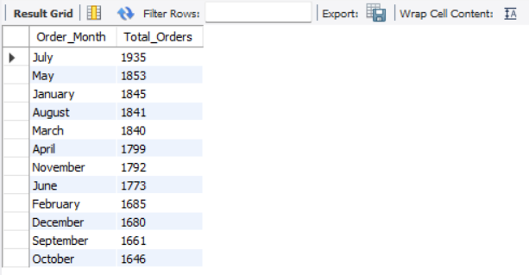

1. **Percentage of Sales by Pizza Category**

* SELECT pizza_category,

CAST (SUM (total_price) AS DECIMAL (10,2)) AS Total_sales,

CAST (SUM (total_price) * 100 / (SELECT SUM (total_price) FROM pizza_sales)

AS DECIMAL (10,2)) AS Percentage_Sales

FROM pizza_sales

GROUP BY pizza_category;

OUTPUT:

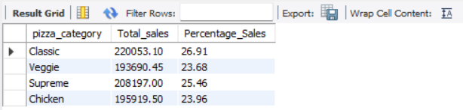

1. **Percentages of Sales by Pizza Size**

* SELECT pizza_size,

CAST (SUM (total_price) AS DECIMAL (10,2)) AS Total_sales ,

CAST (SUM (total_price) * 100 / (SELECT SUM (total_price) FROM pizza_sales)

AS DECIMAL (10,2)) As Percentage_Sales

FROM pizza_sales

GROUP BY pizza_size;

OUTPUT:

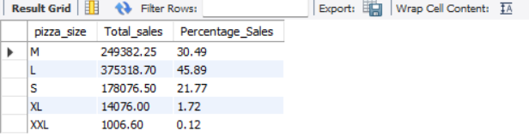

1. **Total Pizzas Sold by Pizza Category**

* SELECT pizza_category, SUM (quantity) AS Total_pizza

FROM pizza_sales

GROUP BY pizza_category;

OUTPUT:

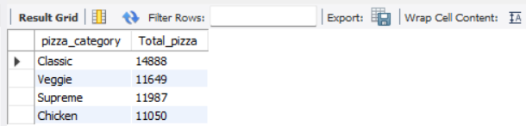

1. **Top 5 Best Sellers by Revenue, Total Quality and Total Orders**

* SELECT pizza_name, SUM(total_price) AS Total_revenue FROM pizza_sales

GROUP BY pizza_name

ORDER BY Total_revenue DESC

LIMIT 5;

OUTPUT:

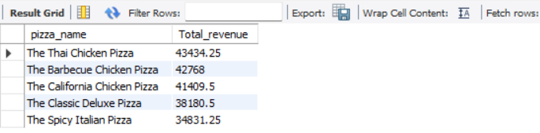

* SELECT pizza_name, SUM (quantity) AS Total_pizza FROM pizza_sales

GROUP BY pizza_name

ORDER BY Total_pizza DESC

LIMIT 5;

OUTPUT:

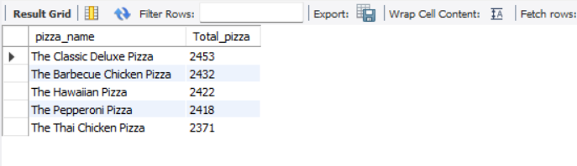

* SELECT pizza_name, SUM (DISTINCT order_id) AS Total_orders

FROM pizza_sales

GROUP BY pizza_name

ORDER BY Total_orders DESC

LIMIT 5;

OUTPUT:

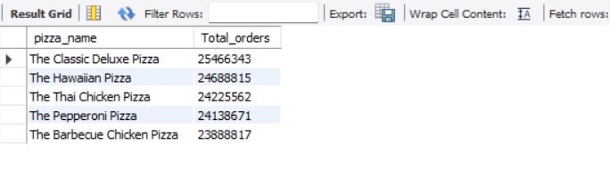

1. **Bottom 5 Worst Sellers by Revenue, Total Quality and Total Orders**

* SELECT pizza_name, SUM(total_price) AS Total_revenue FROM pizza_sales

GROUP BY pizza_name

ORDER BY Total_revenue ASC

LIMIT 5;

OUTPUT:

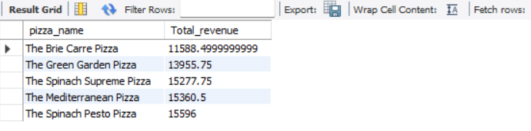

* SELECT pizza_name, SUM (quantity) AS Total_pizza FROM pizza_sales

GROUP BY pizza_name

ORDER BY Total_pizza ASC

LIMIT 5;

OUTPUT:

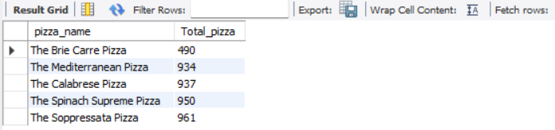

* SELECT pizza_name, SUM (DISTINCT order_id) AS Total_orders

FROM pizza_sales

GROUP BY pizza_name

ORDER BY Total_orders ASC

LIMIT 5;

OUTPUT:

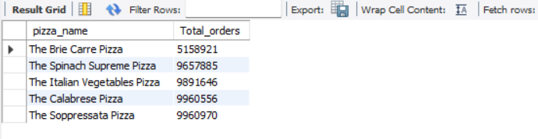

**POWERBI**

Interactive Dashboards

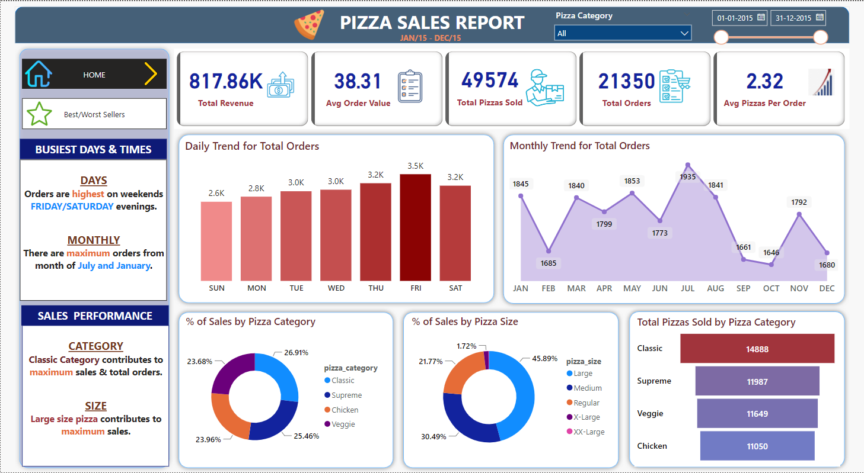

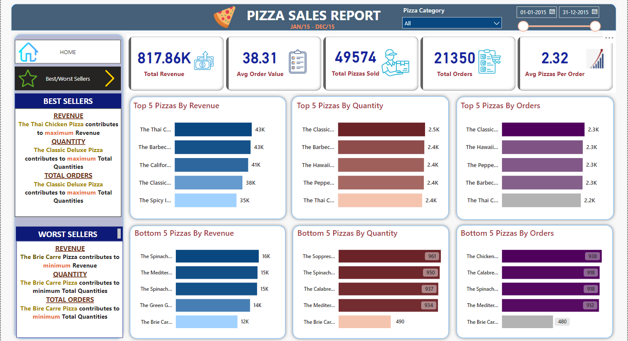

**Reference**

Data Source: <https://www.kaggle.com/code/melikedilekci/eda-pizza-restaurant-sales/input>

Power BI & MYSQL Database Connection: <https://www.youtube.com/watch?v=ZVXiosudsfs&t=125s>

Software used

MS Office: 2403

MYSQL: 8.0.34 (MYSQL Community Server)

POWER BI: 2.124.1554.0 64-bit (December, 2023)